A Guide to MTI’s Report Template

General Instructions
- Please use the customized Styles when writing your report. A table explaining the commonly used styles is shown below (see Table 1). A full list of styles can be found in the Styles Pane.
- Please do not insert section breaks, as this will distort this template’s embedded features. Authors are welcome, however, to insert page breaks as necessary.
- Please do not delete the highlighted endnote near the end of this template; it is a formatting feature that will be cleared during typesetting.
- Authors should use Chicago Manual of Style or APA for references. Authors are asked to use a permalink or URL shortener for long URLs. SJSU has provided guidance on permalinks.
- Authors are not required to complete the Technical Report Documentation Page.
- Authors are asked to draft their table of contents and lists of tables and figures using Microsoft’s automated features (see guidance below regarding using these features).
- Please complete all other sections of the report template, including abstract, research brief, and extended author(s) biographies at the end of this document.
About Generative AI
MTI acknowledges that generative AI is increasingly being used in research and writing workflows. GenAI tools may never be used to fabricate citations, generate fictitious data, or produce analysis that is presented as original research. GenAI may be used as supportive tools for brainstorming, outlining, and even drafting assistance—but never as a replacement for a human’s authentic voice, critical thinking, and original contributions. If generative AI was used to contribute text and/or images to this report, the author(s) must acknowledge this clearly in a concise statement in the report’s Acknowledgments section. The author(s) remain responsible for avoiding plagiarism and copyright infringement and take full responsibility for any content in this report.
Table 1. Overview of Commonly Used Styles in the MTI Report Template
Purpose | Style Name
Main section/chapter headers | (DocBody) SectionHead_Numbered
1st level subheading (in main section or chapter) | (DocBody) L2 Subhead
2nd level subheading (in main section or chapter) | (DocBody) L3 Subhead
3rd level subheading (in main section or chapter) | (DocBody) L4 Subhead
Main text | (DocBody) Body
There are many other styles used throughout the template to assist with final typesetting. Please reach out to MTI staff if you have any questions about structuring your report.

Automated Table of Contents and Lists of Tables and Figures:
- A draft table of contents is provided in this template. As you write your report, please make sure to use the customized styles for the main section/chapter headings and subheadings in each chapter. To update the table of contents, “right-click” in the TOC section and then select ‘Update Field’ and then ‘Update Entire Table.’
- For figures and tables, please first use MS Word tools to insert a caption for a table or figure. To update the list of figures or tables, follow the same procedure used to update the table of contents.
- For troubleshooting automated tables of contents, lists of figures and tables, and automated captions, please see here. Please reach out to MTI staff if you encounter any difficulties with inserting captions or updating the table of contents or list of tables/figures.

Report xx-xx

Title

Shishir Mathur, Ph.D.
Christopher Ferrell, Ph.D.

Month 202x

A publication of the
Mineta Transportation Institute
Created by Congress in 1991

College of Business
San José State University
San José, CA 95192-0219

Technical Report Documentation Page
Authors Do Not Complete
1. Report No. | 2. Government Accession No. | 3. Recipient’s Catalog No.
4. Title and Subtitle |  | 5. Report Date
 |  | 6. Performing Organization Code
7. Authors |  | 8. Performing Organization Report
9. Performing Organization Name and Address  Mineta Transportation Institute  College of Business  San José State University  San José, CA 95192-0219 |  | 10. Work Unit No.
 |  | 11. Contract or Grant No.
12. Sponsoring Agency Name and Address  State of California SB1 2017/2018  Trustees of the California State University  Sponsored Programs Administration  401 Golden Shore, 5th  Long Beach, CA 90802  U.S. Department of Transportation  Office of the Assistant Secretary for  Research and Technology  University Transportation Centers Program  1200 New Jersey Avenue, SE  Washington, DC 20590 |  | 13. Type of Report and Period Covered
 |  | 14. Sponsoring Agency Code
15. Supplemental Notes

16. Abstract

17. Key Words | 18. Distribution Statement  No restrictions. This document is available to the public through The National Technical Information Service, Springfield, VA 22161.
19. Security Classif. (of this report)  Unclassified | 20. Security Classif. (of this page)  Unclassified | 21. No. of Pages | 22. Price
Form DOT F 1700.7 (8-72)

Copyright © 202x
by Mineta Transportation Institute
All rights reserved.

DOI: 10.31979/mti.202x.xxxx

Mineta Transportation Institute
College of Business
San José State University
San José, CA 95192-0219

Email: mineta-institute@sjsu.edu

transweb.sjsu.edu/research/xxxx
Acknowledgments
Text. Add acknowledgments here.

Example acknowledgment text for use of GenAI: [GenAI tool Claude] was used in the [initial outlining of sections A and B] and [GenAI tool ChatGPT] was used to [generate data for Table F]. All material generated by an AI tool included in this document was reviewed and fact-checked by a human to ensure accuracy.
Abstract
Abstracts should:
- Be approximately between 200 and 250 words in length.
- Use reader-accessible language that: 1. Uses accurate but simple word choice, 2. Defines technical terms and industry jargon, 3. Accurately summarizes to present the most relevant information.
- Use 3rd person point-of-view and active voice (e.g. “the research team analyzed data” NOT “data was analyzed by us).
- Engage and sustain reader attention throughout by presenting specific, relevant information using interesting language
- Include the following information whenever possible: research purpose/goals, relevant stakeholders, most important methods, findings and their significance
- Follow this general format:
- Introduce concept
- State research purpose/goal and stakeholders
- Summarize methods
- Explain important findings and their implications

Write your abstract here.

Research Brief Text
(Required, Formatted as Separate Document During Publication Phase)
All MTI reports are accompanied by a research brief. The research brief is a compelling, two-page overview (when formatted) of your research project and key results. This also helps MTI as we consider appropriate ways to highlight and showcase your research through press releases, social media posts, targeted outreach to journalists, etc. – we learn, from your perspective, what really matters with your research. Here are some tips for writing a compelling research brief:
- Frame your topic in a way that makes it entertaining to read.
- Grab the reader with the first paragraph. Use lively language to explain as succinctly as you can what you want the reader to know about your research.
- Write in a professional, yet conversational tone. Use short, powerful, active voice verbs. Keep your sentences short and avoid long clauses. Keep the language straight-forward and not overly complex.
Please provide the content pieces below when you submit your draft report. MTI will submit this text for professional editing along with your report. The maximum number of words is 850 (and the minimum number of words is 750).
Introduction (~150 words)
Write a brief introductory statement about the research. What is important/relevant about your research? What was your primary research question/goal?
Study Methods (~250 words)
Describe the study methods briefly using language lay readers can understand.
Findings (~250 words)
Describe the key findings.
Policy/Practice Recommendations (~150 words)
Describe the policy and/or professional practice recommendations that stem directly from your research findings.
Call-out Box Text (~25 words)
One sentence highlighting an important finding of the research.
Table/Photo
For visual interest, please include a table and/or relevant figure for the research brief.

About the Authors or About the Principal Investigator
Provide a brief “about the authors” section. Note, this will likely be considerably shorter than the full bio that is included within the larger report. Just a sentence or two is all that is needed for the research brief.
Contents

1. Introduction 11
1.1 L2 Subhead Title [(DocBody) L2 Subhead)] 11
1.1.1 L3 Subhead Title [(DocBody) L3 Subhead)] 11
2. Section Title 12
2.1 L2 Subhead Title 12
2.1.1 L3 Subhead Title 12
2.2 L2 Subhead Title 12
3. Section Title 13
3.1 L2 Subhead Title 13
3.2 L2 Subhead Title 13
3.2.1 L3 Subhead Title 13
3.3 L2 Subhead Title 15
4. Summary & Conclusions 16
Appendix A 17
Endnotes 18

List of Figures
Figure 1. Title 14
Figure 2. Title 15

List of Tables
Table 1. Title 12
Table 2. Title 12

- Introduction
Text.

1.1 Hilary
Text.

1.1.1 Alverina
Text.
L4 Subhead Title [(DocBody) L4 Subhead)
Text.
- Section Title
Text.

2.1 L2 Subhead Title
Text.

2.1.1 L3 Subhead Title
Text.
- Title
Heading | Year | Year | Year
Label 1 | x | x | x
Label 2 | x | x | x
Label 3 | x | x | x
Label 4 | x | x | x
Source: text

- Title
Heading | Year | Year | Year
Label 1 | x | x | x
Label 2 | x | x | x
Label 3 | x | x | x
Label 4 | x | x | x
Source: text

2.2 L2 Subhead Title
Text.
- Section Title
Text.

3.1 L2 Subhead Title
Text.

3.2 L2 Subhead Title
Text.

3.2.1 L3 Subhead Title
Text.

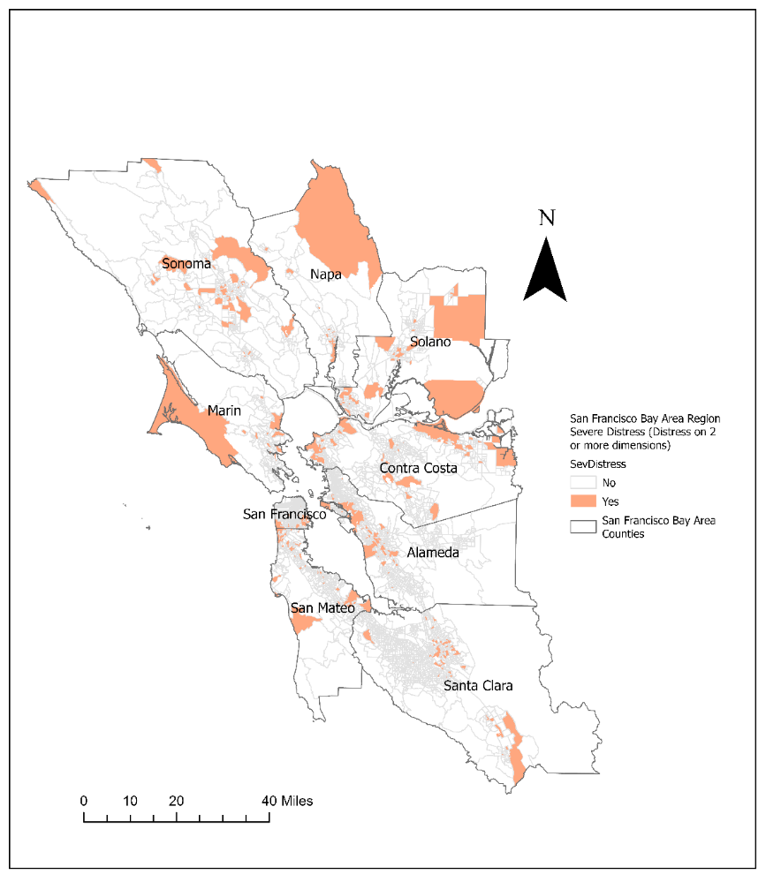
- Title
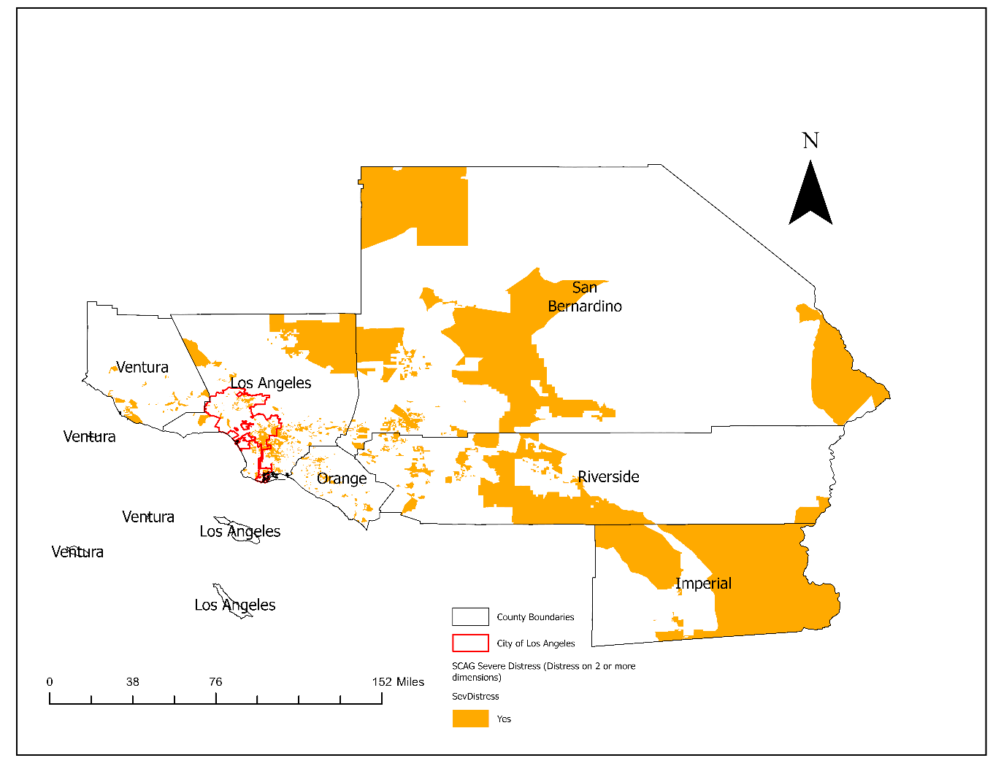
- Title

3.3 L2 Subhead Title
Text.
- Summary & Conclusions
Text.

Appendix A
Text.

Endnotes

Please do not delete highlighted endnote. This will be removed during the typesetting stage by Editing Press. Bibliography All entries must comply with the Chicago Manual of Style or APA. About the Authors Author 1 Short biography. Author 2 Short biography.

