Sponsoring Agency Logo

**ICS and Climate Change on the Railroad:**

**Refreshers**

Sponsored by

XYZ Railroad

**Discussion‐Based Training**

**Scenarios with Rules Instructor’s Notes**

Adapted from NCHRP 20‐59(30) ICS for Field-Level Transportation Supervisors and Staff National Academies of Sciences, Engineering, and Medicine. 2016. Incident Command System (ICS) Training for FieldLevel Supervisors and Staff: NCHRP Web-Only Document 215. https://doi.org/10.17226/23411. Adapted with permission from the National Academy of Sciences, Courtesy of the National Academies Press, Washington, D.C.

# Scenario: Wildland Fire

## Rail Joins ICS

It is September 10 at 10:00 am. There is a wildland fire burning in Hilly County near the town of Foresthill off Yankee Jims Road, which runs parallel to the XYZ Railroad right of way. Fire personnel from ten agencies have responded to the fire, and State Fire Department is the Incident Commander. They have reopened an old fire camp to support operations but access is limited.

You have been assigned to join State Fire Department at their command post. Your mission is to discuss providing access across the railroad right of way to the wildland firefighters, and to see whether they would benefit from access to a fire train. One is available that has a caboose to transport firefighters, and another has a caboose to serves as an on-site Incident Command Post. You will be joining the existing Pollock Pines Incident.

The fire train comes with its two-person crew – engineer and conductor - and can carry up to 20 firefighters in the transport caboose. The train will come full of water, with reels of hose, and a Stang station monitor (large water nozzle) mounted on one of the fire train car roofs. The firefighters would need to provide rehab supplies for their personnel, and be prepared with information on refilling the water tankers as needed. The conductor knows how to operate the front water sprayer and where to attach the hose.

### Discussion:

### 

### Note to Rules Instructor:

If possible set up a table with appropriate small vehicles to represent the Incident Command Post, the Staging Area, the track, the railroad right of way and the main road. Include a motel and restaurant down the main road. Encourage students to move the vehicles around during the discussion to reflect the actions they would take.

1. Where do you go when you get to Yankee Jim Road? It is getting too dark to survey the right of way tonight.

[Discuss the need to go to the Command Post to Check‐In, completing one T card with the name and contact information for the rail representative. It is too dark to survey the right of way.]

2. How will you get food and lodging for tonight?

[Discuss the role of check‐in for getting integrated into the fire camp system. If the fire camp is inaccessible which options do you have for tonight? Does the rail representative have authorization for per diem? ]

3. How will you get access to the fire train? How soon can it be ready to travel?

[Discuss the role of the rail representative in serving as liaison between the railroad and the Incident Commander. How would the representative communicate to get the train to the Incident? How will the safety of the train and its crew be ensured?]

# Scenario: Hurricane

## Railroad Representative as a Technical Specialist in Operations

Hurricane Lulu has developed from a tropical storm into a Category 2 hurricane as it passed over Cuba. Florida has been hit with 120 mile per hour winds and driving rain as the hurricane passed through, and the storm, which is over 500 miles in diameter, has already begun to cause storm surge, flooding and wind damage in your state. Your state’s emergency operations center has been activated, mandatory evacuations of the coast have been underway for several hours, and the State Highway System has traffic jams along most routes moving away from the coast. One of these State Highway System routes is the main street of Leafville, where your railroad has a major maintenance yard and switching siding. Amtrak shares the track and has a small passenger station neat the yard.

Leafville, a community of 10,000 people, 25 miles from the coast, has declared a state of emergency for the impending storm, and begun the evacuation of low lying areas of the community to a shelter at the high school, but it is already full. Center City is 75 miles away and has opened shelters for coastal residents who can get there. Amtrak makes two trips a day that stop at Leafville and then at Center City. Tomorrow will be the last 2 trips before they stop for the storm.

**Discussion:**

[Note to Rules Instructor: set up a table with little cars and buildings to show the location of the Command Post, US Route X through town, the high school, traffic coming from the coast, the rail yard and Amtrak station, some city streets including residential feeder streets, and any other visuals that will help the participants understand the scenario events. Include some traffic control signs, cones or other accessories that might be useful. Encourage students to move the vehicles and traffic control devices around, or introduce more vehicles and traffic control devices from a staging lot at the side of the table.]

1. You have been assigned to be the technical specialist because you have lived in the community for twenty years and been through several hurricanes and tropical storms. What personal supplies and equipment would you need?

[Discuss weather-related clothing in case of needing to make field surveys of conditions, camera/cell phone to record conditions, which railroad street vehicle to use for personal transportation to the command post and potentially around the community. How will you communicate back to the railroad maintenance yard for additional information or resources?]

2. It appears that the Operations Section needs some specialist information on possible assistance that the railroad could provide to the community. What information will you need to have with you to provide this assistance?

[Discuss where you can get information about Amtrak service, about the flood safety of the XYZ railroad’s track and right of way, about the railroad’s ability to help with post-storm debris removal from the community and disaster supplies into the community. How about moving first responders and their equipment into the community – electric utility personnel and their trucks, for example, if roads are impassable.]

3. It appears that there is no plan for people with access and functional needs to get to a shelter, or for parking the vehicles of the evacuees once the school’s lot is full. What information would you need to bring to the command post to help develop such plans? What resources does Amtrak have? Would the XYZ Railroad be willing to allow shelter cars in their employee lot? What identification would be required and how could right-to-park signs be provided to the evacuees?

[Discuss what kinds of flood maps you would need and whether they are available on your smart phone, and what would be the best strategy for getting information during the on-going storm conditions? Can Amtrak take the access and functional needs residents to Center City for shelter? Who would coordinate that? NGO?]

# Scenario: Flooding

## Railroad Representative in Unified Command

The Mississippi River is swollen with spring melt from the snow and ice that has accumulated in communities along its length throughout the winter of 2015. Oakton is a town of 50,000 people on the western banks of the Mississippi River. It draws its drinking water from the Mississippi River at the northern boundary of the town, disposes of its storm water runoff along the length of the city’s shoreline, and its water treatment plant effluent in the river about five miles south of the drinking water intake.

The railroad track crosses the Mississippi River after it passes through Oakton and after crossing the river is in another state. The railroad’s bridge carries the electrical power grid connection cables, phone and internet fiber optic lines, and a natural gas line. This is the only bridge across the river for ten miles north and ten miles south. The bridge approach crosses some low lying areas that are prone to flooding, however most of the track is elevated as it passes through the town.

About 25% of the town is below the river and protected by a levee that is owned by the Army Corps of Engineers. It has only 500 year flood protection. Most of the town is in a 100 year flood plain. The main commercial district of the community is in the flood plain. The only hospital is in the flood plain, and the only large rehabilitation center is next door to the hospital, in the flood plain. The local government buildings are on raised pads but are in the commercial district in the flood plain. Two of the four fire stations are in the flood plain and the police station is in City Hall, on a raised pad but in the flood plain. The Public Safety Answering Point (9-1-1 center) is in the City Hall but on the 4th floor. There are six assisted living centers in town, of which five are in the flood plain. The only commercial day care center is in the flood plain.

The state’s hydrologist has warned that the river is flooding north of Oakton. The mayor has declared a local emergency, and has all available city resources sandbagging critical buildings. The city’s emergency operations center is open and the police chief has just called for an evacuation of the critical facilities in the flood plain. The Oakton Fire Chief has been appointed Incident Commander and is working with city staff from law enforcement, the building department and the streets department to create a multi-modal evacuation plan. He has asked the railroad to join the Unified Command, and they have to send a representative.

### Discussion:

[Note to Rules Instructor: set up a table with little cars and buildings to show the location of the Command Post, the river, the flood plain, critical buildings in the flood plain (fire stations, city hall, shops, hospital/rehab center), the levee, the main street, rescue vehicles remaining at the Command Post and any other visuals that will help the participants understand the scenario events.]

1. Who would be the best person to represent the railroad in the Unified Command?

[Discuss what the purpose of the Unified Command is. Discuss who has participated in local exercises with the community. Consider what kinds of requests might come from the Unified Command to the railroad.]

2. What would the railroad’s objectives be for an evacuation plan? [Discuss what role the railroad plays in the local multimodal transportation system. What role is it likely to play in an emergency response plan? What steps would need to be taken by the railroad to protect its assets?]

3. What resources does the Maintenance District have that might be useful in an evacuation of the flood plain? In a response to a flood?

[Discuss the use of rolling stock for moving goods usually moved by truck on roads that are now flooded. Does the railroad have any assets to move evacuees out or first responders in? What train traffic is at risk of disruption? Is the right of way safe from flooding or will operations have to stop? Discuss how the railroad would get reimbursed for its costs in providing staff and resources for community support, like facilitation of the delivery of critical supplies like drinking water.]

# Scenario: Bridge Collapse

## State DOT Assumes Incident Command

It is November 15. Three days ago a deck truss railroad bridge over the Old Muddy River collapsed at the end of rush hour when a barge with an oversize load ran into one of the supports, which led to the structural failure. City Fire Department was the initial Incident Commander because there were people trapped on ferry boats now blocked from their landing by the bridge collapse. During this time the State Police led the Law Enforcement Branch of the Operations Section. They closed the adjacent street and detained the barge operator, did a blood alcohol and drug test and interviewed him. He stated that the wind on the river caused him to lose control of the wide load, which shifted as he approached the steel support that he hit. The State Police cleared him of drug or alcohol involvement.

One railroad civil engineer was a Technical Specialist in the Operations Section to advise on issues of bridge construction and failure. Other railroad personnel were assigned to the Logistics Section where they organized bridge inspection equipment and other specialized equipment to assist with the early investigation of the failure. As soon as the ferry passengers were rescued the Incident Command was turned over to State Police on Day Two, and they did a crime scene investigation of the portions of the bridge still standing to confirm the barge operator’s story. Having completed their investigation they are turning over Incident Command to the railroad today.

You have been appointed the railroad’s Incident Commander for the first day.

### Discussion:

[Note to Rules Instructor: set up a table with little cars and buildings to show the location of the Command Post, the broken bridge, rescue vehicles remaining at the Command Post and any other visuals that will help the participants understand the scenario events. Encourage students to move the vehicles around or introduce more vehicles from a staging lot at the side of the table.]

1. Where will you go to assume Incident Command?

[Discuss the location of the Incident Command Post, and what information you could get from current staff who are working in the ICS now.]

2. What documentation would you need from the departing Incident Commander? [Discuss the existence of an Incident Action Plan. Where would you get a copy? How would you document the turnover of command from Law Enforcement? Would the new IC ask the departing IC to remain for an hour until all of the transition of operations to the railroad has been completed? What about supplies that have been ordered and not delivered? Expenses from before you assumed command? Photos that have been taken? What is the prognosis for the event?]

3. Where would you get personnel to fill the ICS positions? Which would you fill with rail personnel and which would you request to fill with personnel from other agencies? Why?

[Discuss what positions would be needed by rail for a complete ICS staff. How soon could they arrive? Discuss other sources of personnel to fill specialty roles. Ensure that departing ICS staff leave contact information with new staff for follow-up.]

# Rules Instructor’s Guide: Sandbox Method of Exercises

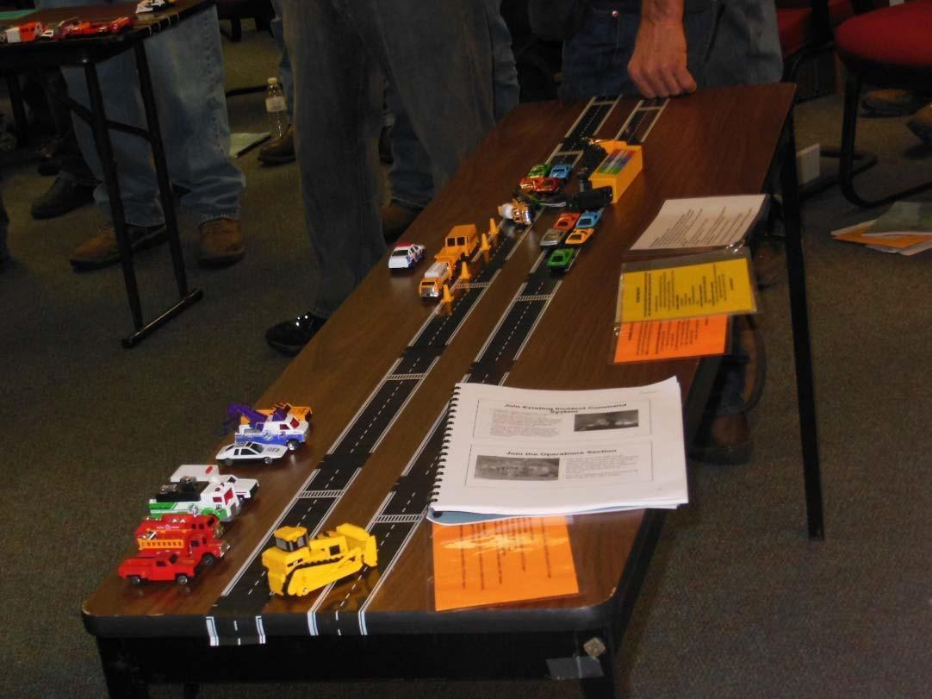

Note the engineer’s tape creating the “highway”, the simulated accident with the little cars, the emergency vehicles in Staging, the student book with the scenario, and the Quick Start Card sets that are distributed to students to help them work through the scenario.

The purpose of the Sandbox Method is to help students visualize the movement of personnel and equipment through a scenario as they practice their Incident Command System knowledge and terminology. This system has long been used by the US military to work an operational problem, or to explain an operational plan. Field personnel are accustomed to thinking on their feet, and are likely to appreciate a kinesthetic approach to exercising their critical thinking skills and knowledge of a problem. Adult learning theory suggests that most adults remember best what they hear, see and do. The Sandbox Method incorporates these elements.

HO trains and Matchbox type cars can be bought in sets from internet resources that include construction equipment, cones and signage. Emergency responder vehicles and passenger cars also come in sets. You can use little buildings to complete the community, but these can be expensive. For a more flexible and cost‐effective approach, create a building foot print with a sheet of plain cardstock cut to relative scale to represent significant buildings, parking lots, parks and other aspects of the community. Label the cards, or draw symbols on them to identify the building or community element that the card represents.

As students work through the scenario they can move the vehicles and traffic control devices, and block roads to simulate the progress of the problem.

As you demonstrate scenarios you will develop a collection of community element footprint cards that can be reused. The vehicles can be used for training in many configurations.