Lesson 1: What Do You Know About Transportation?

WHAT DO YOU KNOW ABOUT TRANSPORTATION STUDENT WORKSHEET
Complete the following worksheet listing all that you know about the following:

- What are the different ways we use transportation? (e.g. get to school)

- What are the different modes of transportation? (e.g. car)

- What are the different energy sources used by transportation? (e.g. gas)

- What are some of the environmental impacts of transportation? (e.g. smog)

1. Uses | 2. Modes | 3. Energy Sources | 4. Effects

Lesson 2: Key Innovations in Transportation

KEY INNOVATIONS IN TRANSPORTATION TIMELINE STUDENT HANDOUT

DATE | EVENT
August 1803   | Robert Fulton creates a steamboat that operates up the River Seine in Paris, moving 3-4 miles per hour upstream.
May 1869   | Passenger traffic begins on the first pneumatic subway invented by Alfred Ely Beach. The Beach Pneumatic Underground Railway of New York City includes a 312 foot-long circular tube, 9 feet in diameter. The cars carry 22 passengers and are propelled by a blast of air from a rotary blower.
January 1900  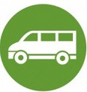 | The first electric bus appears on 5th Avenue in New York City. It seats eight people inside and four outside. The fare is 5¢.
October 1904 | The New York City Subway is the first rapid transit underground and underwater railway in the world. It runs from City Hall to West 145th St.
April 1913 | The first electrically propelled ship of the U.S. Navy, the USS Jupiter, is commissioned.
November 1923  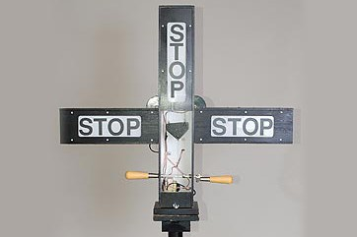 | Garrett Morgan is granted a patent for inventing the first practical traffic signal.
March 1927 | The first automobile to exceed 200 miles per hour is the “Mystery Sunbeam” driven by Major Henry O’Neil de Hane Segrave at Daytona Beach, FL. He hits  203.79 mph.
September 1931 | An experimental electric passenger train, designed by Thomas Alva Edison, is used on the Lackawanna Railroad between Hoboken and Montclair, NJ.
July 1935 | The first parking meter, called The Black Mariah, is installed in Oklahoma City, OK.
June 1956  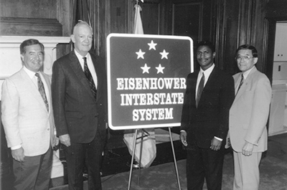 | President Dwight Eisenhower signs a bill that creates the first interstate highway in the U.S. The system is not completed until 1990.

DATE | EVENT
August 1959 | An early modern type of magnetic levitation (maglev) train is described in a US Patent by G.R. Polgreen.
April 1961   | The first human spaceflight is Vostok I, on which cosmonaut Yuri Gagarin of the USSR makes one orbit around Earth.
October 1964  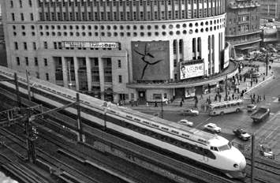 | Japan’s Shinkansen, the first “bullet train,” opens.
January 1969 | An oil well blows out on a Union Oil Company drilling platform five miles off the coast of Santa Barbara, CA. The beaches are covered with oil. In April 2010, the same thing happens in the Gulf of Mexico, where BP was drilling.
July 1979 | President Carter announces a massive six-point effort to reduce American dependence on foreign oil, including alternative energy development.
March 1989  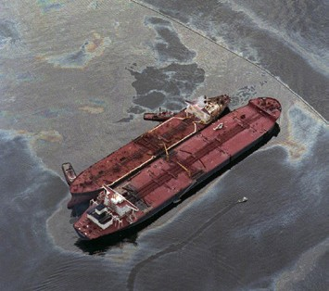 | Exxon Valdez oil tanker runs aground in Alaska, spilling 232,000 barrels of oil. Only 25% of the migratory salmon population returns the following season.  Thousands of otters and birds are poisoned. Many die.
July 2006  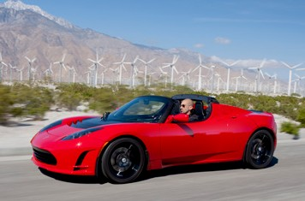 | The Tesla Roadster is introduced at the Santa Monica, CA airport at a  350-person invitation-only event. The Roadster costs more than $100,000.
August 2008  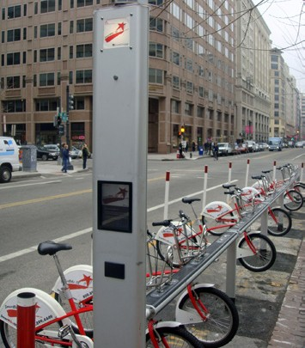 | SmartBike DC in Washington. D.C. launches the first docked bike sharing system.

DATE | EVENT
March 2009   | Uber, a ride-hailing company, launches in San Francisco, CA.
April 2009 | President Obama unveiled his administration’s blueprint for a national network of high-speed passenger trains.
December 26, 2009  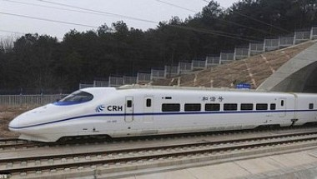 | China introduced the world’s fastest train, with average speeds of 217 miles per hour.
July 2012 | California legislature under Gov. Jerry Brown approves the construction of a high-speed system.
May 2013 | The New York Times runs a story about young people leading a trend toward driving less and taking transit instead.
October 2014  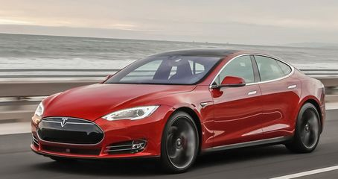 | Tesla releases the Model S, the first electric, semi-autonomous vehicle for general use.
January 2015  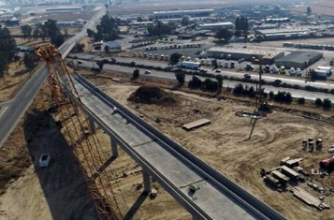 | California High Speed Rail breaks ground in Fresno.
September 2016 | The U.S. Department of Transportation announces new regulations for automated vehicles and self-driving cars to ensure that they are safe.
December 2016 | Tesla CEO Elon Musk founds The Boring Company with the goal of creating a subterranean tunnel system for passenger vehicles. The company is also working on hyperloop technology.

April 2017  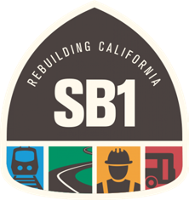 | California Senate Bill 1 passes passes. This “gas-tax” collects funds to repair roads, improve traffic safety, and expand public transit systems in California.
April 2017 | The highly controversial Dakota Access Pipeline has a 168 gallon crude oil leak. The pipeline had several other leaks throughout 2017-2019.
DATE | EVENT
September 2017  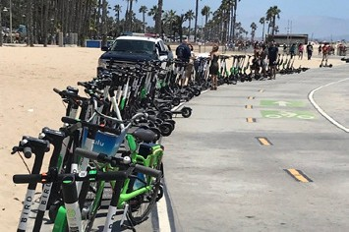 | Dockless e-scooters launch in Santa Monica, CA with mixed reviews due to lack of laws and regulations on micromobility.
January 2018 | Brightline high-speed train in Florida opens for public operation between West Palm beach and Fort Lauderdale.
October 2018  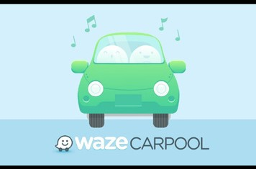 | Waze launches carpool matching feature nationwide. The company predicts it will reach 1M carpool rides by 2020.
July 2019 | Uber reveals its helicopter ride-share service, Uber Copter.
October 2019  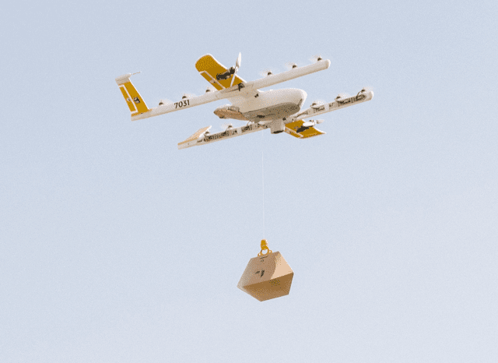 | Wing launches first commercial drone delivery.
October 2021  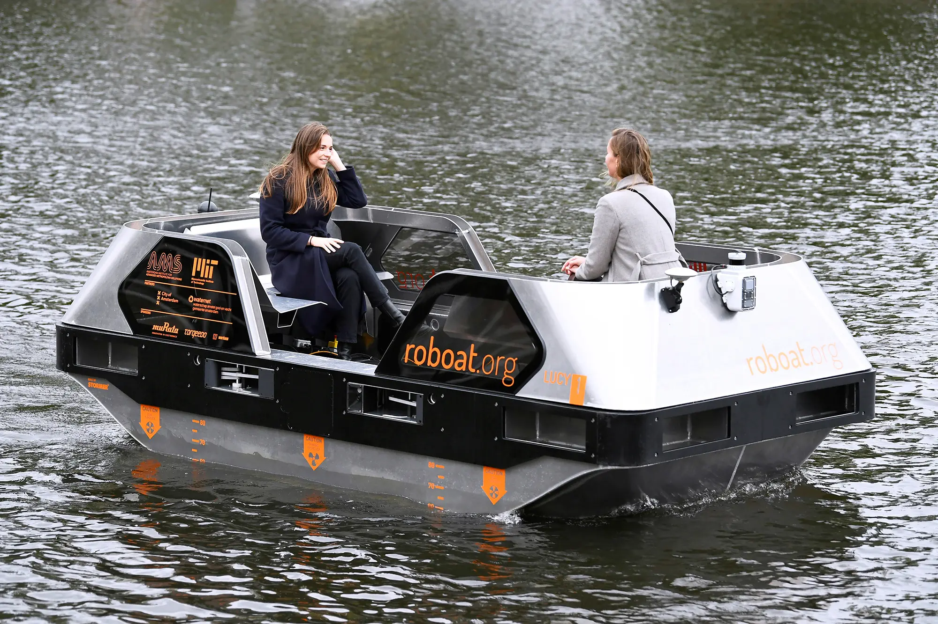 | The world’s first urban autonomous water vessels, Roboats, are deployed in the canals of Amsterdam. The vessels can be used to carry up to five people, collect waste, or deliver goods.
January 2022 | A driverless bullet train that can transport 564 passengers at 217 mph is revealed in China in time for the Winter Olympics.
February 2022 | Autonomous Vehicle company Cruise launches a robotaxi line in San Francisco, CA that is open to the public.
August 2022 | The first rail line running entirely on hydrogen power debuts in Germany. The trains are expected to keep 4,000 tons of carbon dioxide out of the atmosphere each year.

- Identify three items from the timeline that you could see being adapted today to create a more sustainable mode of transportation. Jot down how beside the event.

- Circle those items on the timeline that MOST negatively impact the environment.

- Place a dollar sign symbol [$] beside those events on the timeline that generate money for city improvements or maintenance.

- Discuss and compare your results.

Lesson 3: Learning About Transportation Fuels

TRANSPORTATION FUELS STUDENT ACTIVITY GUIDELINES
In groups, you will learn about a specific transportation fuel and present what you have learned to your class. The focus is on fuels used primarily by cars and trucks, as well as buses.
- Read the “Alternative Fuels Information Student Worksheet – Background” to learn some background information about transportation fuels, particularly the role of petroleum and why people are looking at alternative sources of fuel.

- Read the “Alternative Fuels Student Information Worksheet” for the fuel your group has been assigned (e.g. gasoline, diesel, biodiesel, etc.).

- As a group, develop a list of facts that you want to teach your class about your fuel. In addition to the Information Worksheet, you may want to consult some additional resources, either those listed on the worksheet or other resources identified by your teacher. Here is a list of questions to help you gather information:

  - Is your fuel renewable or nonrenewable?

  - How is your fuel made?

  - Is your fuel available in your area?
(hint: consider looking at the Department of Energy’s Alternative Fuel Station Locator at: http://energy.gov/maps/alternative-fueling-station-locator)

  - What types of vehicles can use your fuel? (check out www.fueleconomy.gov for information about what cars used alternative fuels)

  - What are the costs associated with your fuel?

  - What are the challenges to developing a widespread market for your fuel?

  - Would you buy a vehicle that uses your fuel? Why or why not?

- Prepare a visual aid with information about your fuel. Your teacher will provide additional information about the size and specific contents for your visual aid. Write them down here:

- Prepare a short oral presentation for your class about your fuel. Your teacher will provide additional information about the size and specific contents for your presentation. Write them down here:
Lesson 4: Our Class Transportation Carbon Footprint

TRANSPORTATION CARBON FOOTPRINT STUDENT WORKSHEET

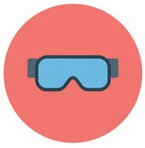
INTRODUCTION
Roughly one-quarter of U.S. greenhouse gas emissions come from the transportation sector: trains, planes, boats, trucks, cars, etc.5 Choices made everyday about how to get to school, work, the mall, etc., directly impact the size of your CO2 “footprint.”

Your CO2 “footprint” is basically a measurement of how much carbon dioxide is emitted into the atmosphere as a result of an individual’s consumption of fossil fuels. Transportation choices are just one component of a CO2 footprint – but can often be the most significant.

How big is your transportation footprint? And how does it compare with that of your classmates?

Through this activity you’ll conduct a survey to identify the different modes of transportation you and your classmates use to get to and from school. You’ll then use this information to calculate the combined impact of those choices on your CO2 footprint.

ASSIGNMENT STEPS
- Find out the round trip distance from your home to school. You can either do this by noting the mileage while doing the journey or go to an online map program (e.g. maps.google.com) and put in the correct addresses to calculate the distance.

Roundtrip distance to and from school: Miles

- If you travel to and from school in a car (either alone or in a carpool), determine the average fuel economy of that vehicle in miles per gallon by checking www. fueleconomy.gov. (Hint: use the Find a Car feature and enter the year, make, and model to get the fuel economy.) Write that information below.

Fuel economy: Miles per gallon

5. U.S. Environmental Protection Agency, 2016. “Sources of Greenhouse Gas Emissions.” Accessed October 20, 2016 from https://www.epa.gov/ghgemissions/sources-greenhouse-gas-emissions.

3. How do you typically get to and from school? In the table below, find the option which best fits your mode of transportation and then complete the relevant section.

If you get to and from school by... | Complete the following section:
Car, driving alone | Section A
Carpool – with other students from your school | Section B
Bus – public or school bus | Section C
Micromobility- electric scooter, bike, unicycle, etc. | Section D
Walk, bike, or other zero-emission mode | Section E

SECTION A: TRANSPORTATION = CAR, DRIVING ALONE 
Complete the following:

- Estimate gallons of gas consumed each day getting to and from school. Show your work.

Answer: gallons of fuel consumed

- Calculate the CO2 emissions of your commute. Each gallon of gasoline burned emits 20 lbs of CO2. Show your work.

Answer: lbs CO2 emitted getting to and from school

- Estimate your annual CO2 emissions from getting to and from school. Multiply your total from #2 above by 180 school days. Show your work.

Answer: lbs CO2 emitted getting to and from school

- Estimate your CO2 footprint of your school from transportation. What if every stu- dent at your school produced the same amount of CO2 as you, just by getting to and from school? What would your school’s CO2 footprint from transportation be? Multiply your answer from #3 by the number of students at your school. Show your work.

Answer: lbs CO2 generated per year by the whole school

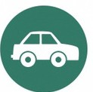
SECTION B: TRANSPORTATION = CARPOOL

Complete the following:

- Estimate gallons of gas consumed each day getting to and from school. Show your work.

Answer: gallons of fuel consumed

- Calculate the CO2 emissions of your commute. Each gallon of gasoline burned emits 20 lbs of CO2. Show your work.

Answer: lbs CO2 emitted getting to and from school

- Calculate your individual impact. How many people shared your ride? Divide your total from #2 by the number of people in your carpool (include yourself!) to calculate the individual CO2 emissions of each person in the carpool. Only include students from your school in your carpool calculation. Do not include others (e.g. driver, sib- lings at other schools, etc.).

Answer: lbs CO2 emitted per person

- Estimate your annual CO2 emissions from getting to and from school. Multiply your total from #3 above by 180 school days. Show your work.

Answer: lbs CO2 emitted per person per year
- Estimate your CO2 footprint of your school from transportation. What if every student at your school produced the same amount of CO2 as you, just by getting to and from school? What would your school’s CO2 footprint from transportation be? Multiply your answer from #4 by the number of students at your school. Show your work.

Answer: lbs CO2 generated per year by the whole school

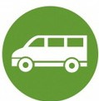
SECTION C: TRANSPORTATION = BUS (PUBLIC OR SCHOOL BUS)

Complete the following:

- Estimate the amount of fuel used by the bus. Buses get about 5 miles per gallon of diesel. Calculate the gallons of diesel used by the bus. Show your work.

Answer: gallons of fuel consumed

- Calculate the CO2 emissions of your commute. Each gallon of diesel burned emits 22 lbs of CO2. Calculate the amount of CO2 generated by the bus for each roundtrip journey. Show your work.

Answer: lbs CO2 emitted getting to and from school

- Calculate the CO2 emissions per passenger. How many people shared your ride? Estimate the number of students who rode the bus with you today. Then calculate the CO2 lbs emitted per passenger on the bus. Show your work.

Answer: lbs CO2 emitted per person

- Estimate your annual CO2 emissions from getting to and from school. Multiply your total from #3 above by 180 school days. Show your work.

Answer: lbs CO2 emitted per person per year
- Estimate your CO2 footprint of your school from transportation. What if every student at your school produced the same amount of CO2 as you, just by getting to and from school? What would your school’s CO2 footprint from transportation be? Multiply your answer from #4 by the number of students at your school. Show your work.

Answer: lbs CO2 emitted per year by the whole school


SECTION D: TRANSPORTATION = MICROMOBILITY (ELECTRIC SCOOTER, BIKE, ETC.)
Complete the following:

- Estimate how much CO2 charging your device costs. A shared electric scooter, on average, takes 6 hours to fully charge and has the battery power to be ridden for 20 miles. This equates to a charge time of 18 minutes per mile. Combined with the
487.37 (little more than 1 lbs.) grams of CO2 emitted per kilowatt-hour, the electricity needed to charge a scooter per mile results in the release of 146.21 grams (.32 lbs) of CO2. Show your work.

Answer: lbs of CO2 emitted getting to and from school

- Estimate your annual CO2 emissions from getting to and from school. Multiply your total from #3 above by 180 school days. Show your work.

Answer: lbs CO2 emitted per person per year

- Estimate your CO2 footprint of your school from transportation. What if every student at your school produced the same amount of CO2 as you, just by getting to and from school? What would your school’s CO2 footprint from transportation be? Multiply your answer from #2 by the number of students at your school. Show your work.

Answer: lbs CO2 emitted per year by the whole school

SECTION E: TRANSPORTATION = WALK, BIKE, SKATEBOARD, OR OTHER EMISSION-FREE MODE OF TRANSPORT
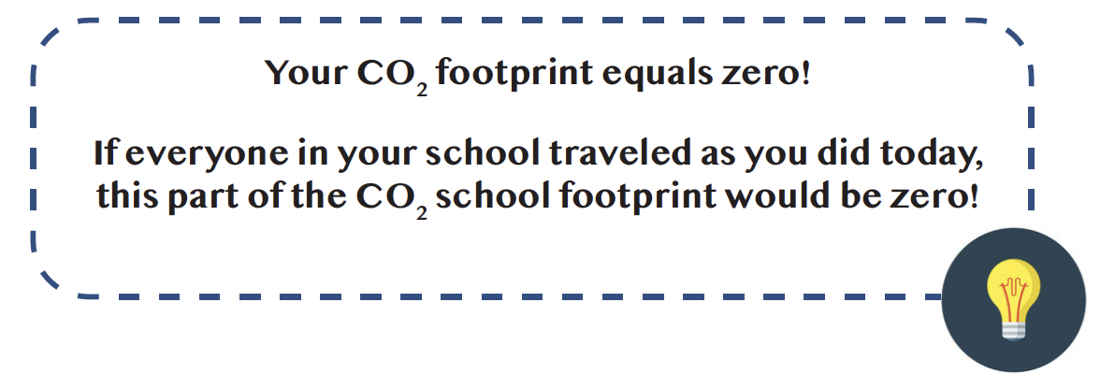

TRANSPORTATION CARBON FOOTPRINT DATE SUMMARY TABLE
Record each student’s data in the table below and add up the CO2 emissions for the entire class.

Student | Pounds of CO2 per year

Total for the class:

Lesson 5: Pretzel Power Exploring Fuel Efficiency

THE CAR LOT
Record each student’s data in the table below and add up the CO2 emissions for the entire class.

 | EPA Class | Vehicle | Combined Miles Per Gallon (MPG)
1 | Two-seater | Smart EQ for two (coupe) (EV) | 108
2 | Minicompact | Fiat 500e (EV) | 112
3 | Subcompact | BMW i3s (EV) | 113
4 | Compacts | Volkswagon e-Golf (EV) | 119
5 | Midsize | Hyundai Ioniq Electric (EV) | 136
6 | Large | Tesla Model S Long Range (EV) | 111
7 | Fuel-economy | Toyota Prius Prime (EV) | 133
8 | Sml. Station Wagon | Chevrolet Bolt (EV) | 119
9 | Midsize Station Wagon | Volvo V90 FWD | 27
10 | Two-seaters | Bugatti Chiron,Lamborghini Aventador Coupe, Lamborghini Roadster | 11
11 | Minicompact | Ferrari GTC4Lusso | 13
12 | Subcompact | Roush Performance Stage 3 Mustang | 15
13 | Compacts | Rolls-Royce Dawn | 14
14 | Midsize | Bentley Mulsanne | 12
15 | Large | Rolls-Royce Ghost, Rolls-Royce Phantom | 14
16 | Sml. Station Wagon | Buick Regal TourX AWD | 24
17 | Midsize Station Wagon | Rolls-Royce Cullinan | 14

Lesson 6: Moving Beyond the Automobile Film Guides

BUS RAPID TRANSIT (https://www.youtube.com/watch?v=YGxr2l0cUvM)
Synopsis: BRT provides faster, more reliable bus service, and has the potential to meet more remote locations in a city. BRT advantages often include exclusive lanes for bus-only use, special waiting stations up on a platform with advance payment, and buses are given priority at intersections.

- What are the critical components that distinguish Bus Rapid Transit (BRT) from regular bus service?

- Where are the best Bus Rapid Transit Systems in the world?

- What are the benefits of Bus Rapid Transit?

- How is BRT less expensive than building other forms of public transit, like a subway, for example?

- Why is it important to improve bus ridership?

- What are some of the problems with buses in your community?

- What changes do you think would make bus riding more popular? Would BRT be a good option?

CARSHARING (https://www.youtube.com/watch?v=-Ef9helWgy4)
Synopsis: Carsharing reduces the number of car trips an individual takes and allows people to avoid buying a car. It also encourages transit ridership, walking, and biking, except at times when a car is necessary.

- What are the personal benefits of carsharing or ridesharing?

- What are the shared benefits of carsharing or ridesharing?

- How has carsharing been incorporated into public transportation systems?

- How do cities support car sharing?

BICYCLING AND MICROMOBILITY (https://www.youtube.com/watch?v=OB_hkWKH7NA)
Synopsis: Many trips people take each day are within reasonable biking or walking distance. Investing in cycling infrastructure by cities is necessary to help reduce traffic congestion and pollution, as well as provide an affordable form of transportation and exercise.

- What are some of the benefits of cycling?

- How is a network of bicycling infrastructure, traffic calming measures, and repair shops a crucial component of promoting cycling as mode of transportation?

- In the US, nearly half of all trips are shorter than three miles; how is cycling a better option than adding more infrastructure for cars?

- Could improving networks that empower alternative, sustainable modes of transportation also improve accessibility and equity in different neighborhoods? How can infrastructure changes (e.g., creating new bike lanes) take issues of equity into account?

TRANSPORTATION AND HAPPINESS (https://vimeo.com/732542898)
Synopsis: Dr. Yingling Fan, a professor at the University of Minnesota and a research scholar at its Center for Transportation Studies, wants to transform the way we experience transportation. With the help of Minneapolis–St. Paul residents, Dr. Fan has developed an innovative “Transportation Happiness Map” that captures the positive emotions tied to biking, reliable public transportation, safe and scenic paths, and avoiding traffic behind the wheel.

- How is happiness affecting the way people commute and experience transportation?

- How can different community members utilize the “Transportation Happiness Map” to envision, plan, and build a more sustainable transportation ecosystem? Think of some action items for the following members:

  - Transportation planners
  - Local government officials
  - Citizens
  - Students

CONCLUDING QUESTIONS
- How do these films convey more sustainable ways of getting around our cities and towns? Do they empower you to think about walking, cycling, or using the bus in new ways?

- Do you think one of these choices would work better for your community than others? Which one and why?

- Could these methods of getting around be used in conjunction with each other? For example, do you think people would bike to a bus station?

- How can policymakers, planners, and citizens ensure that sustainable transportation options reach those who most need it, including traditionally underserved communities?

Lesson 7: How Walkable is Your Community?

Name:

STUDENT WORKSHEET/CHECKLIST

Location of Walk :

Rating Scale :

- Did you have room to walk?
Yes Some problems:
Sidewalks or paths started and stopped
Sidewalks were broken or cracked
Sidewalks were blocked with poles, signs, shrubbery, dumpsters, etc.
No sidewalks, paths, or shoulders
Too much traffic
Something else:

Rating (circle one)
1 2 3 4 5
Locations of problems:

- Was it easy to cross streets?
Yes Some problems:
Road was too wide
Traffic signals made us wait too long or did not give us enough time to cross
Needed striped crosswalks or traffic signals
Parked cars blocked our view of traffic
Needed curb ramps or ramps needed repair
Something else:

Rating (circle one)
1 2 3 4 5
Locations of problems:

- Did drivers behave well?
Yes Some problems:
Backed out of the driveways without looking
Did not yield to people crossing the street
Turned into people crossing the street
Drove too fast
Sped up to make it through traffic lights or drove through traffic lights
Something else:

Rating (circle one)
1 2 3 4 5

Locations of problems:

- How about safety? Could you and your child…
Yes No Cross at crosswalks or where you could see and be seen by drivers?
Yes No Stop and look left, right and then left again before crossing streets?
Yes No Walk on sidewalks or shoulders facing traffic where there were no sidewalks?
Yes No Cross with the light?

Rating (circle one)
1 2 3 4 5

Locations of problems:

- Was your walk pleasant?
Yes Some problems:
Needed more grass, flowers, or trees
Scary dogs
Scary people
Not well lighted
Dirty air due to automobile exhaust
Something else:

Rating (circle one)
1 2 3 4 5

Locations of problems:

How does your neighborhood stack up?
Add up your ratings and decide

Total:

26-30 Celebrate! You have a great neighborhood for walking.
21-25 Celebrate a little. Your neighborhood is pretty good.
16-20 Okay, but it needs work.
11-15 It needs lots of work. You deserve better than that.
5-10 It’s a disaster for walking!

Lesson 8: Transportation Jobs and Professions

CAREER FLOWCHART HANDOUT
MINETA UNIVERSITY

COLLEGES | APPLIED SCIENCES AND ART COLLEGES | BUSINESS COLLEGE | EDUCATION COLLEGE | ENGINEERING COLLEGE | ARTS AND LETTERS COLLEGE | SCIENCE COLLEGE | SOCIAL SCIENCES COLLEGE
MAJORS | Aerospace | Accounting/ Finance | Child and Adolescent Development | Aviation and Technology | Art | Biological Science | Cultural Studies
 | Health/ Nursing | Management Information Systems | Counselor Education | Chemical and Materials Engineering | Dance | Chemistry | Communications
 | Hospitality/ Recreation | Marketing/ Business | Education Leadership | Civil and Environmental Engineering | Design | Computer Science | Economics
 | Journalism and Communications | Organization/ Management | Elementary Education | Computer Engineering | English | Geology | Environmental Studies
 | Social Work |  | Secondary Education | Electrical Engineering | Languages | Mathematics | Geography
 |  |  |  | Industrial Engineering | Music | Meteorology | History
 |  |  |  | Mechanical and Aerospace Engineering | Philosophy | Marine Biology | Political Science
 |  |  |  |  | Radio, TV, Film | Physics | Sociology
 |  |  |  |  | Animation/ Illustration | Astronomy | Urban Studies

CAREER FLOWCHART HANDOUT
MINETA UNIVERSITY

COLLEGES | APPLIED SCIENCES AND ART COLLEGES | BUSINESS COLLEGE | EDUCATION COLLEGE | ENGINEERING COLLEGE | ARTS AND LETTERS COLLEGE | SCIENCE COLLEGE | SOCIAL SCIENCES COLLEGE
CAREER EXAMPLES | Aircraft Designer | Human Resources | Corporate Trainer | Pilot and crew | Translator | Environmental Technician | Law
(Feel free to add some of your own) | Inspection Officer | Finance Team |  | Energy manager | Public relations/ media contact | Health & Safety Specialist | City Planner
(Feel free to add some of your own) | Aerospace Technician | Labor Relations |  | Production manager | Communications | Nurse | Transportation Planner
(Feel free to add some of your own) | Drone/ Payload Specialist |  |  | Chemical quality control | Advertising | EMT | Environmental
(Feel free to add some of your own) | Public Relations/ Communications |  |  | Water treatment | Copywriter | Research Assistant | Lobbyist
(Feel free to add some of your own) | Law Enforcement |  |  | Auto mechanic |  |  | Law Enforcement
POSSIBLE EMPLOYERS (Can you think of some possible employers to add?)

CAREER FLOWCHART HANDOUT
MINETA UNIVERSITY

COLLEGES | APPLIED SCIENCES AND ART COLLEGES | BUSINESS COLLEGE | EDUCATION COLLEGE | ENGINEERING COLLEGE | ARTS AND LETTERS COLLEGE | SCIENCE COLLEGE | SOCIAL SCIENCES COLLEGE
PERSONAL PROS & CONS

Lesson 9: Understanding Sustainable Transportation

UNDERSTANDING SUSTAINABLE TRANSPORTATION STUDENT WORKSHEET

By now you already know a lot about transportation. If somebody asked you what sustainable transportation was, you’d probably have quite a bit to say. You could tell them about the different fuels available and explain the various social, economic, and environmental costs associated with them. You could also talk about why transportation must be convenient and fast so people will use it. You could explain benefits and drawbacks of mass transportation. How much the transportation costs and whether it can be made available to all are other issues that you might discussion with someone who asked you about transportation.

But it someone asked you for a definition of sustainable transportation, you might have a bit of trouble. People who work on many issues related to sustainability have developed the following definition: “meeting the needs of the present without compromising the ability of future generations to meet their own needs.”

When you think about it, this definition includes many possibilities related to transportation. What might those be? Sustainable transportation can include using mass transit, like buses, trains, light rail, and carpools. It could also be about using fuel efficiently. It can be about how employers address transportation issues by allowing employees to telecommute, have staggered shifts, or work longer hours so they don’t have to make so many trips to work or drive during rush hours. All of these concepts, and many others, are part of sustainable transportation.
CHARACTERISTICS OF SUSTAINABLE TRANSPORTATION
Complete the table below to identify and explain six desirable characteristics of sustainable transportation.

Characteristic | Why is it desirable?

ASSESSING SUSTAINABLE TRANSPORTATION OPTIONS
List four sustainable transportation modes and several positive and negative attributes of each.

Mode | Positive Attributes | Negative Attributes

