**Quick Start Card Masters**

Printable masters are provided in the ICS Support Materials folder in Word format for ease of customization.

Current layout is designed to maximize the use of paper and minimize labor by printing two cards per sheet of paper, double sided.

Cards are intended to be modified by state and local jurisdictions to coincide with their specific safety and response protocols.

**Directions: instructional videos are available at** [**https://vimeo.com/showcase/11005939**](https://vimeo.com/showcase/11005939)

**Video 4 t 4:56, and Video 4A provide detailed instructions.**

Print out the sheets of cards to make a master set

Match the front and back of each card, and print each card double sided on the selected color.

Cut in half to create 2 cards.

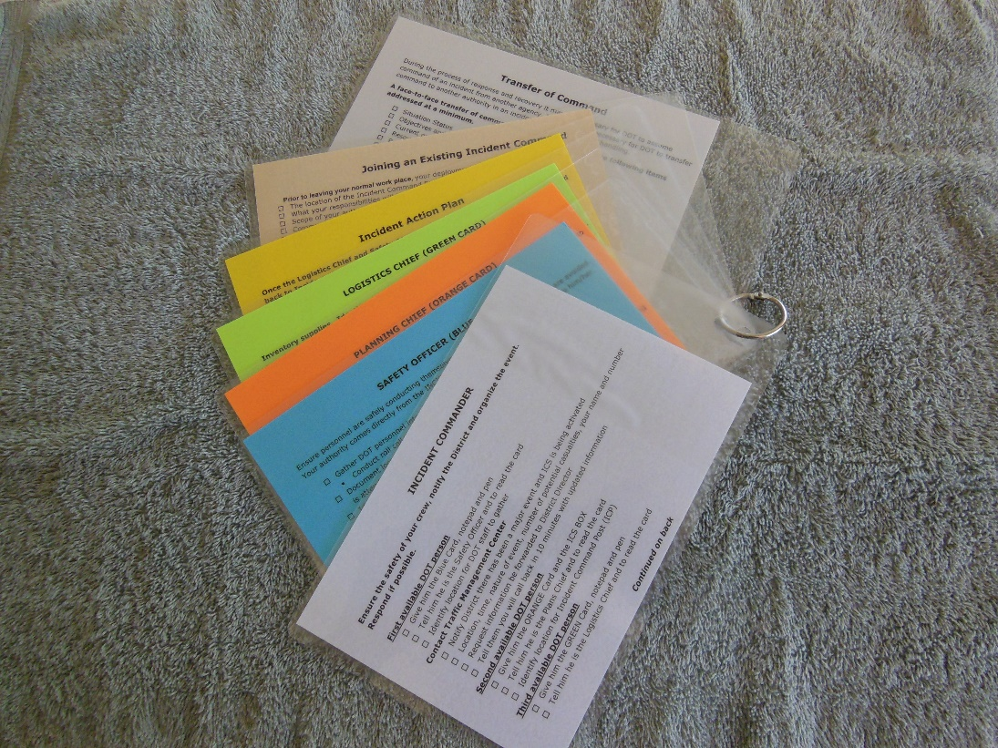

**Quick Start Cards Supplies and Equipment**

These instructions presume that the cards will be made within the agency. Commercial production and assembly has been estimated at $30 per set, while internal production is about $10 for materials and labor if a laminating machine is available. A new lamination machine costs less than $100, and a corner rounder is about $40 . Other items are typical office supplies.

**Supplies and equipment:**

7 different colors of 24 lb. paper, 8.5” x 11” (white, blue, orange, green, yellow, brown, gray – or light tone colors that are available in agency stock, and change the cards’ color references to reflect the match of color and position/activity)- makes 2 cards per sheet; one of each color per set

9” x 11.5” / 5 mil lamination sheets – makes 2 cards each

1” loose leaf rings, 1 ring per set

Lamination machine – Apache AL13P Professional Thermal Laminator was used for the project. Other laminators are available at a lower cost but may not stand up to the production demands of the project. If an internal machine is already available, for example for making badges, it may be adequate as along as it accepts large enough sheets.

10 mm radius corner punch rounder

Paper cutter

Hole punch/paper punch

**Directions:**

1. Print out card masters double sided; cut into single cards

2. Laminate 2 cards per sheet, place to allow space between cards for cutting

3. Round all corners – lamination is sharp

4. Punch hole in one corner

5. Assemble set on ring, one color each in uniform order – Incident Commander, Safety Officer, Planning Chief, Logistics Chief, Incident Action Plan, Joining and Existing Incident Command, Transfer of Command

**Supervisor’s Folder Description, Materials List and Construction Instructions**

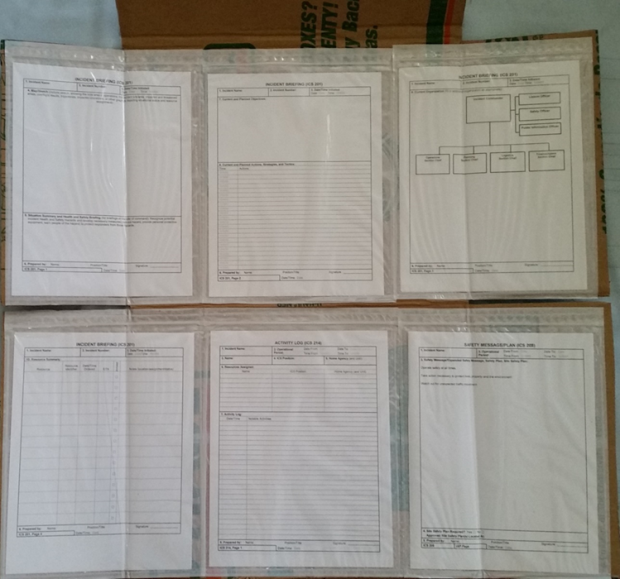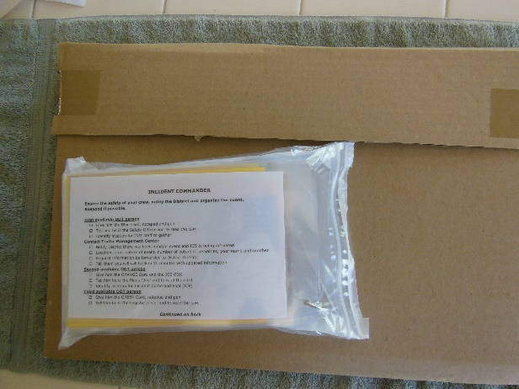

The Supervisor’s Folder. Note the top flap of cardboard that serves as both the closure and the hanging point. Note the placement of the forms across the panel, with the side flaps folding the envelopes as the folder is closed. On the right is the folded version with the blister pack of supplies in place.

**Supplies: Folder Construction: instructional video is available at** [**https://vimeo.com/showcase/11005939**](https://vimeo.com/showcase/11005939)**, video 4.**

Boxes – 6 panel – holds 6 different forms = medium size U-Haul boxes – 18” length x 18” width x 16” height, $1.35/box, yields 2 folders

8 panel – holds 8 different forms = 24” length x 18” width x 18” height- $3/ box, yields 2 folders

Zip lock top packing envelopes – “clear re-closable packing list enclosed envelope, plain face, back load (self-adhesive), 2.0 mil thick, 9” x 12”. Need 6 or 8 per panel, plus one for outside blister pack (see below). Available in 500 per case quantity” about $.18 each

ICS forms, available on-line for download, <http://www.training.fema.gov/emiweb/is/icsresource/icsforms.htm>

should be printed on one side only except for the ICS-214 and instructions on how to fill out forms. These forms could be downloaded into a mobile device for use, as well.

**Supplies Pack**

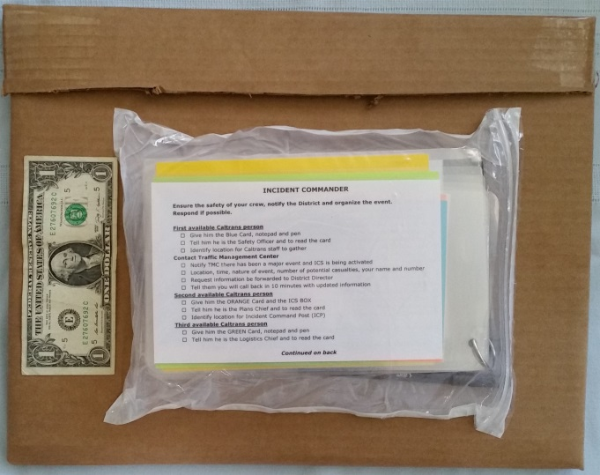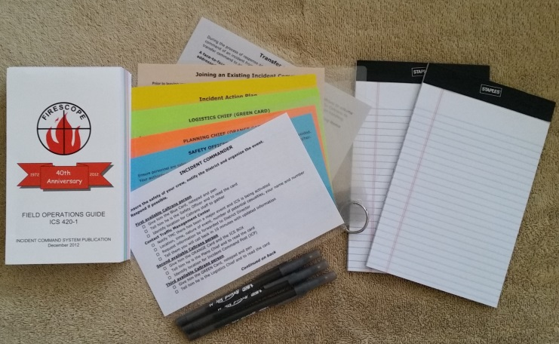

ICS Field Operations Guide – FEMA downloadable for printing (about $30 each) or mobile devices [http://www.usfa.fema.gov/downloads/pdf/publications/field_operations_guide. pdf](http://www.usfa.fema.gov/downloads/pdf/publications/field_operations_guide.%20pdf)

ICS FOG may be purchased from FIRESCOPE for $6 each

<http://www.firescope.org/fog-order-info.htm>

5” x 8” white pads, 50 sheets per pad

3 ballpoint pens

1 set of Quick Start Cards created using instructions above

**Equipment**

Box cutter

**Directions for Folder: included in Video 4 at** [**https://vimeo.com/showcase/11005939**](https://vimeo.com/showcase/11005939)

1. Identify the ICS forms needed by your agency’s field crew: recommended 201 (4 sheets), 208, 214, and

2. Determine the number of panels required for these forms when printed one-sided, except for 214.

3. Purchase appropriate sized boxes to accommodate 6 or 8 forms.

4. Print 2 of each form per folder to be made, plus one set of instructions for each form

5. Place 2 copies of each form and one set of instructions in each packing envelope

6. Locate the seam where the cardboard overlaps on the box, use a box cutter to cut that seam. And the seam on the opposite edge of the box. You now have 2 equal cardboard panels.

7. Take one panel, turn sideways so that the flaps are on the right and left sides, with the advertising or writing on the box facing up.

8. Lay out the forms on the marked (advertising) side of the box so that they coincide with the seam in the middle being the folding point, with half of the envelopes above the fold and half below.

8. Adhere the form envelopes to the box by removing the paper covering the self-adhesive surface.

9. Use box cutter to trim bottom and sides to match packing envelopes.

10. On top cut the excess flap material from each side, leaving the center panel top intact.

11. Fold in flaps on the bottom and top portions of the cardboard; fold bottom half upward onto the top half; fold the remaining center portion to overlap the bottom half.

12. Use packing tape on edges of top flap to seal.

**Directions for Supplies Pack: included in Video 4 at** [**https://vimeo.com/showcase/11005939**](https://vimeo.com/showcase/11005939)

Take one packing envelope, with clear side facing up, open zip lock and insert 2 pads, 3 pens, the ICS FOG 420 . Put the Quick Start Cards on top with the Incident Commander card facing out.

Reseal the zip lock top of the envelope.

Turn over so adhesive side is facing up, peel off backing, fold side edges on envelop ½” in so adhesive sides stick to themselves.

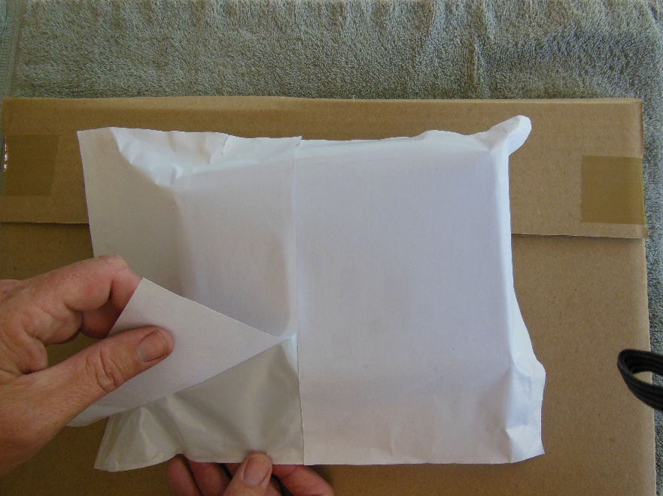

Fold in bottom ½” so adhesive edge sticks to itself.

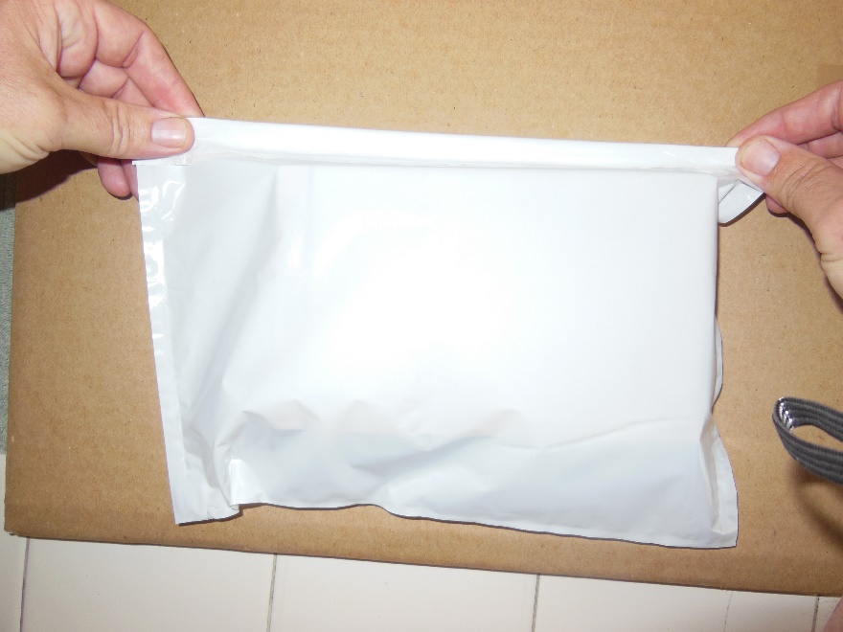

Grasp top corners of bag (edge with zip lock), position bag bottom first on the back of the cardboard folder, then lay down, and press FIRMLY into the cardboard. Press around edges to ensure full adhesion to cardboard.

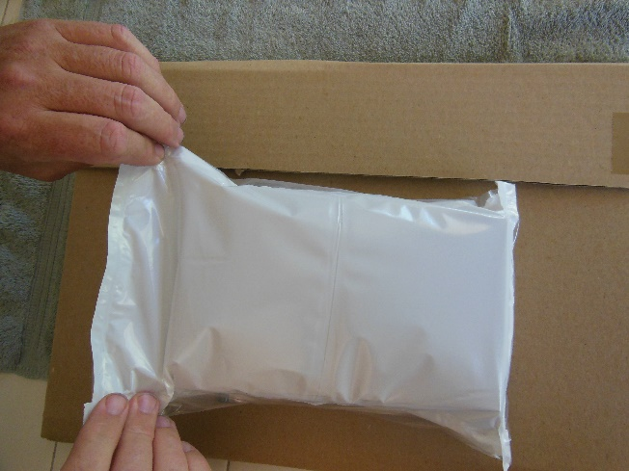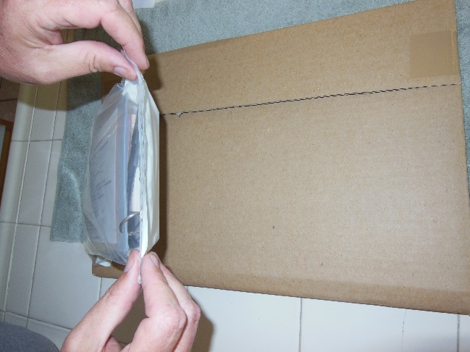

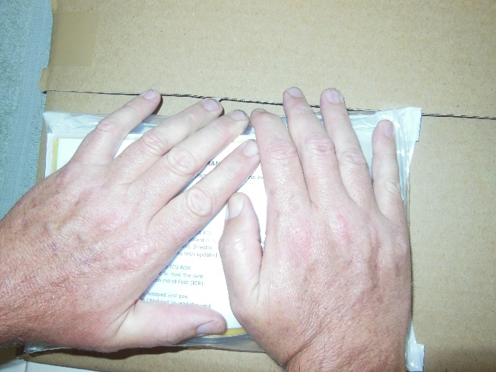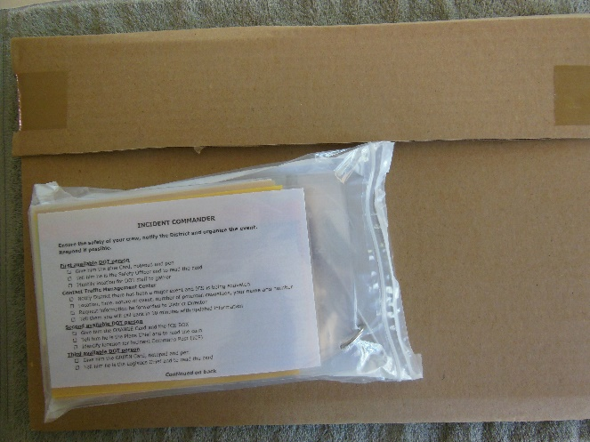

**MATERIALS, AUDIO VISUAL, AND MISCELLANEOUS**

**Audio Visual Needs:**

* PowerPoint presentation
* Laptop computer with appropriate power connection
* Projector on cart or table with appropriate power connection, and cable for laptop
* Screen
* Three 6’ or longer tables
* Microphone (optional)

**Props:**

* Sets of 1:64 vehicles (Matchbox, Hot Wheels or similar), including police(2-6), fire(2-6), ems (2-4), heavy equipment(4-8), media truck (2) and personal (20) vehicles, road cones, road signage and 2 tanker trucks
* Civil Engineer’s tape
* Completed Supervisor’s Folder
* 10 sets of Quick Start ICS cards

**Handout Materials per Pupil:**

* Student Manuals as appropriate for lessons to be covered: ICS, Briefing Training, Discussion-Based Scenarios
* Course Evaluation sheets for each element taught – Modules 1a, 1b and 2 on one sheet
* ICS Field Operations Guide, 420 (FEMA version may be downloaded and printed at about $30 per book; FIRESCOPE ICS FOG 420 can be purchased on-line for $6/book plus shipping) <http://www.firescope.org/fog-order-info.htm>

**Seating Arrangement:**

* Students in classroom style set up in any configuration that allows a clear view of the screen from every seat and adequate width to open the student manuals, and a view of one of the “accident” set up tables
* Rules instructors in front of the classroom where they can be easily heard by the students, and control the slide show

**Table Set Up:**

* One table at the front of the classroom to accommodate the rules instructor, laptop and rules instructor’s written materials
* Tables and chairs for students with one student manual and one FOG manual per student on the tables, and one set of Quick Start ICS cards for each table up to 10 tables. If there are additional tables place one set of cards for every 2 tables.
* Two tables set up as an accident scene. Use these instructions to create 2 different set ups on 2 tables, one on each side of the front of the room. Using Civil Engineer’s tape create a “highway.” Place the tanker truck on its side obstructing the highway, and about 10 personal vehicles in rear end collisions, “spinouts” and other accident-type positions. Place the heavy equipment in a reasonable configuration for highway work just ahead of the accident scene. Place the police, fire, EMS and media vehicles and the cones and signs at the end of the road. These will be introduced into the accident scene as the scenario using ICS unfolds.

National Academies of Sciences, Engineering, and Medicine. 2016. Incident Command System (ICS) Training for FieldLevel Supervisors and Staff: NCHRP Web-Only Document 215. https://doi.org/10.17226/23411. Adapted with permission from the National Academy of Sciences, Courtesy of the National Academies Press, Washington, D.C.